DOG KENNEL HILL PRIMARY SCHOOL
School Closure Weekly Timetable
Year 3

 | Monday | Tuesday | Wednesday | Thursday | Friday
English  Everyday:  Reading (20-30 mins)  https://home.oxfordowl.co.uk/reading/  Handwriting practise (Twinkl Common Exception Words): https://www.twinkl.co.uk/resource/year-3-year-4-statutory-spelling-words-handwriting-activity-sheets-t-e-2549615  Spelling Task: http://www.ictgames.com/mobilePage/lcwc/index.html  Phonics (If your child usually has additional phonics sessions):  https://www.phonicsplay.co.uk/#  Username: march20  Password: home | Write a description about your favourite place in the world. What does it look and smell like? Who else is there? What can you do there?  Comprehension Task:  https://www.twinkl.co.uk/resource/t2-e-3760-lks2-reading-comprehensions-bumper-resource-pack | Summarise the story of the Iron Man in no more than 2 paragraphs.  Comprehension Task:  https://www.twinkl.co.uk/resource/t2-e-3760-lks2-reading-comprehensions-bumper-resource-pack | Write an acrostic poem using the word London:  Lively streets filled with Londoners  Our home is what we call it!  N  D  O  N  Comprehension Task:  https://www.twinkl.co.uk/resource/t2-e-3760-lks2-reading-comprehensions-bumper-resource-pack | Write a book review about your favourite book:  - Title  - Author  - Description of your favourite character  - Your favourite part of the story  - Draw your favourite scene from the book  Comprehension Task:  https://www.twinkl.co.uk/resource/t2-e-3760-lks2-reading-comprehensions-bumper-resource-pack | Write about what you did today or this week using fronted adverbials:  First, I woke up.  Then, I brushed my teeth.  Next, I had breakfast.  After that, I spoke to my friend on the phone.  …  Comprehension Task:  https://www.twinkl.co.uk/resource/t2-e-3760-lks2-reading-comprehensions-bumper-resource-pack
Maths  Game idea:  Play a game of ‘Place Value War’  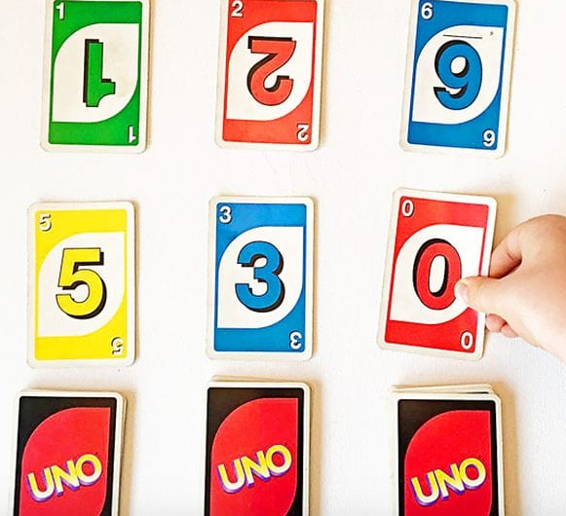  Play this game with Uno cards or a classic deck with face cards removed. Each player has a number of piles (depending on which place values you’re working on) and lays down the top card from each. The players say the resulting numbers out loud (e.g. “five hundred thirty”) and the player with the highest number wins. For a fun variation, allow players to use the cards they flip to create the highest possible number. | Times Table Rock Stars  https://ttrockstars.com/  Mental Arithmetic  https://www.topmarks.co.uk/maths-games/daily10  Complete level 3, addition, Two-digit numbers.  Maths with Parents Task:  https://www.mathswithparents.com/  Measuring and Comparing length- complete set tasks  Class: Palm  Class Code: 611884  Class: Elder  Class Code: 909646 | Times Table Rock Stars  https://ttrockstars.com/  Mental Arithmetic  https://www.topmarks.co.uk/maths-games/daily10  Complete level 3, addition, Three-digit numbers and ones.  Maths with Parents Task:  https://www.mathswithparents.com/  Measuring and Comparing Mass – complete set tasks  Class: Palm  Class Code: 611884  Class: Elder  Class Code: 909646 | Times Table Rock Stars  https://ttrockstars.com/  Mental Arithmetic  https://www.topmarks.co.uk/maths-games/daily10  Complete level 3, addition, Three-digit numbers and tens  Maths with Parents Task:  https://www.mathswithparents.com/  3-digit partitioning  Class: Palm  Class Code: 611884  Class: Elder  Class Code: 909646 | Times Table Rock Stars  https://ttrockstars.com/  Mental Arithmetic  https://www.topmarks.co.uk/maths-games/daily10  Complete level 3, addition, Three-digit numbers and hundreds.  Espresso Maths Task:  https://central.espresso.co.uk/espresso/modules/m2_measures/index.html?source=subject-Maths-KS2-Maths-Resource%20types  If the link doesn’t work sign into https://central.espresso.co.uk/ and follow these steps - Key Stage 2, Maths, Measures- Activities  Username: student21515  Password: dkh846 | Times Table Rock Stars  https://ttrockstars.com/  Mental Arithmetic  https://www.topmarks.co.uk/maths-games/daily10  Complete level 3, addition, Bonds to make 1,000  Complete any of the maths tasks unfinished from this week.  Challenge:  https://central.espresso.co.uk/ and follow these steps - Key Stage 2, Maths, Measure challenge zone upper or lower (your choice)  Test your knowledge on length or weight.  Username: student21515  Password: dkh846
Indoor Exercise | Cosmic Kids Yoga  https://www.youtube.com/user/CosmicKidsYoga  Joe Wicks  https://www.youtube.com/playlist?list=PLyCLoPd4VxBvQafyve889qVcPxYEjdSTl  Go Noodle:  https://www.gonoodle.com/ | Just Dance Kids  https://www.youtube.com/watch?v=ziLHZeKbMUo  Joe Wicks  https://www.youtube.com/playlist?list=PLyCLoPd4VxBvQafyve889qVcPxYEjdSTl  Go Noodle:  https://www.gonoodle.com/ | Cosmic Kids Yoga  https://www.youtube.com/user/CosmicKidsYoga  Joe Wicks  https://www.youtube.com/playlist?list=PLyCLoPd4VxBvQafyve889qVcPxYEjdSTl  Go Noodle:  https://www.gonoodle.com/ | Just Dance Kids  https://www.youtube.com/watch?v=ziLHZeKbMUo  Joe Wicks  https://www.youtube.com/playlist?list=PLyCLoPd4VxBvQafyve889qVcPxYEjdSTl  Go Noodle:  https://www.gonoodle.com/ | Cosmic Kids Yoga  https://www.youtube.com/user/CosmicKidsYoga  Joe Wicks  https://www.youtube.com/playlist?list=PLyCLoPd4VxBvQafyve889qVcPxYEjdSTl  Go Noodle:  https://www.gonoodle.com/
Foundation Subjects | Science  Gravity, air resistance and friction:  https://www.twinkl.co.uk/resource/t2-t-452-the-force-of-gravity-activity-sheet | Geography  Volcano Fact File Task:  https://www.oddizzi.com/wp-content/uploads/2017/05/CORE-KS2-ODDIZZI-EARTHQUAKES-FACTFILE-Learning-Zone.pdf  Username: DKHStudent  Password: DKHlogin | History  Read through the different events that happened during the Iron Age and put them in order:  https://www.twinkl.co.uk/resource/t2-h-338-iron-age-timeline-posters | Art/DT  Think about what makes a healthy meal.  Research and design a healthy meal for you and your family.  Use this site for ideas or ask a grownup:  https://www.bbcgoodfood.com/recipes/collection/kids-cooking  If you can with help from a grownup, cook the healthy meal of your choice. Think about measurements as you do this (it will help with your maths)  Take pictures | ICT/Coding  Download Scratch Junior – free coding app.  Can you create your own interactive story or game- make your characters move, jump, dance and even sing!  https://www.scratchjr.org/
Project Work/PSHE/citizenship  Everyday: https://www.skillsbuilder.org/homelearning​ | Let’s Wonder:  Who is in your child’s immediate family? What other relatives do they have?  How does their family link together? How many people do they have in their  family? Why not spend time looking through old photos and talking about  the people in their families. What family stories can they tell? How is life different to their parents? grandparents? | Let’s Create:  Create a piece of artwork entitled ‘Family’. This could be a drawing, a self portrait, a sculpture or collage. Could they copy another artist's style? Which materials have they chosen to use and why? How do they feel about their piece of artwork? What would they change or not? Family portraits. | Time to Talk:  Perhaps they could play a board game, facetime a member of their family they have not seen this week, enjoy a family indoor picnic or have a family dinner. | Understanding Others and Appreciating Differences:  Discuss how their family is different to other people’s families. Discuss whether all families are the same? Does it matter? Do all families have the same faith? Do all families worship in the same way? | Reflect:  Find out what music their family members enjoy. Do they like the same music? What is their favourite song? They could listen to different pieces of music together with their family. Do they like/dislike any particular types of music and why? Can they Identify the instruments they can hear and describe how the music makes them feel? Why not get them to listen to some of the classics?
Mindfulness/  Wellbeing  Other options:  Headspace: (free)  https://www.headspace.com/subscriptions  Breath and Body:  https://it.pearson.com/content/dam/region-core/italy/pearson-italy/pdf/Docenti/breath_and_body.mp3 | Guided meditation:  https://www.youtube.com/watch?v=64QzBuhsyuk | Guided meditation:  https://www.youtube.com/watch?v=neqwDPmn6yY | Guided meditation:  https://www.youtube.com/watch?v=DWOHcGF1Tmc | Guided meditation:  https://www.youtube.com/watch?v=mV9BBR1RoGg | Guided meditation:  https://www.youtube.com/watch?v=Iuzy79GGZWU

