DOG KENNEL HILL PRIMARY SCHOOL
School Closure Weekly Timetable
Year 5
Week 2
 | Monday | Tuesday | Wednesday | Thursday | Friday
English | Reading  (20-30 mins)  Choose a story to read and discuss with someone at home. Remember to complete your reading record afterwards  Writing Task: Creative Writing  Watch “Ride of Passage”  https://www.youtube.com/watch?v=29fIGIr0cuQ  Once you have watched the video, Create a comic strip to show what happens in the story. Split your page into squares, draw pictures and below each below describe what is happening. Remember to follow the order of events in the story | Reading  (20-30 mins)  https://home.oxfordowl.co.uk/reading/reading-age-9-10-year-5/  Choose a story to read and discuss with someone at home  Writing Task: Creative Writing  Describe a setting  Look at the picture below and list some descriptive words and phrases, eg vibrant, colourful orchids as bright as light bulbs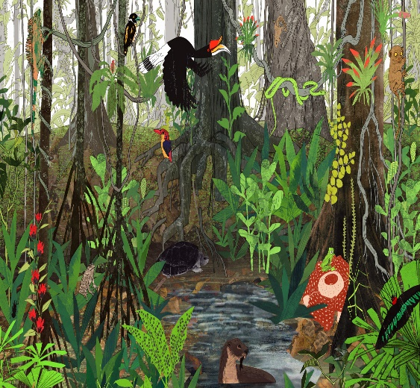  Next, explore SENSES and list what you think you might  SEE, TASTE, FEEL, HEAR, SMELL in the Rainforest, eg HEAR: the squawking of birds filled the steamy air. Remember to include figurative language, eg a massive waterfall crashed and tumbled, tickling the rocks below. | Reading  (20-30 mins)  Choose a story to read and discuss with someone at home. Remember to complete your reading record afterwards  Writing Task: Creative Writing  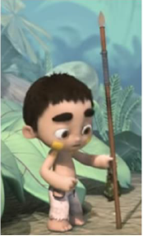  Describe the main character.  List a description of the main character and include some similes and good adjectives and expanded noun phrases: his skin, hair, face, eg his hair was messy and tangled with a little frog sprawled over it | Reading  (20-30 mins)  https://home.oxfordowl.co.uk/reading/reading-age-9-10-year-5/  Choose a story to read and discuss with someone at home  Writing Task: Creative Writing  Key events:  - The boy gets ready to go hunting  - The boy begins to follow a monkey  - The boy senses that something is watching him  Task: Write 3 short paragraphs, following the 3 key events above. | Reading  (20-30 mins)  Choose a story to read and discuss with someone at home. Remember to complete your reading record afterwards  Writing Task: Creative Writing  Key events:  - The boy discovers a giant lizard  - The lizard gets trapped  - The boy helps it to escape  Task: Write 3 short paragraphs, following the 3 key events above.
Maths | Mental Arithmetic  https://www.topmarks.co.uk/maths-games/7-11-years/mental-maths  Choose one of the games to practice arithmetic skills  White Rose Task  https://wrm-13b48.kxcdn.com/wp-content/uploads/2020/homelearning/year-5/Y5-Spring-Block-3-WO1-Decimals-up-to-2-dp-2019.pdf | TTRS (log in to practise times tables)  https://www.mathswithparents.com/  Rowan Class Code: 952318  Complete set task on Place Value  Sycamore class code: 110608 | Mental Arithmetic  https://www.topmarks.co.uk/maths-games/7-11-years/mental-maths  Choose one of the games to practice arithmetic skills  White Rose Task  https://wrm-13b48.kxcdn.com/wp-content/uploads/2020/homelearning/year-5/Y5-Spring-Block-3-WO2-Decimals-as-fractions-1-2019.pdf | TTRS (log in to practice times tables)  https://www.mathswithparents.com/  Rowan Class Code:  952318  Complete set task on Place Value  Sycamore class code: 110608 | Mental Arithmetic  https://www.topmarks.co.uk/maths-games/7-11-years/mental-maths  Choose one of the games to practice arithmetic skills  White Rose Task  https://wrm-13b48.kxcdn.com/wp-content/uploads/2020/homelearning/year-5/Y5-Spring-Block-3-WO3-Decimals-as-fractions-2-2019.pdf
Indoor Exercise | Cosmic Kids Yoga  https://www.youtube.com/user/CosmicKidsYoga  Joe Wicks  https://www.youtube.com/playlist?list=PLyCLoPd4VxBvQafyve889qVcPxYEjdSTl | Just Dance Kids  https://www.youtube.com/watch?v=ziLHZeKbMUo  Joe Wicks  https://www.youtube.com/playlist?list=PLyCLoPd4VxBvQafyve889qVcPxYEjdSTl | Cosmic Kids Yoga  https://www.youtube.com/user/CosmicKidsYoga  Joe Wicks  https://www.youtube.com/playlist?list=PLyCLoPd4VxBvQafyve889qVcPxYEjdSTl | Just Dance Kids  https://www.youtube.com/watch?v=ziLHZeKbMUo  Joe Wicks  https://www.youtube.com/playlist?list=PLyCLoPd4VxBvQafyve889qVcPxYEjdSTl | Cosmic Kids Yoga  https://www.youtube.com/user/CosmicKidsYoga  Joe Wicks  https://www.youtube.com/playlist?list=PLyCLoPd4VxBvQafyve889qVcPxYEjdSTl
Foundation Subjects | Science  Earth and Space  http://www.sciencekids.co.nz/sciencefacts/space/solarsystem.html (New Zealand site)  Task 1: Children to read the facts and jot these down in their notebooks  Look through the gallery at the bottom of the page  Task 2: https://spaceplace.nasa.gov/menu/solar-system/  Children navigate this site by clicking on the questions, images of the planets and facts to learn more.  Extension: https://spaceplace.nasa.gov/sun-paper/en/  Make a sun paper using the instructions on the above link. | Geography  Map skills  https://www.ordnancesurvey.co.uk/mapzone/geography  Click on the links to explore map skills through information and games.  Look at ‘Weather and Climate’ to find out more about Britain’s weather. Complete the activities.  Extension:  https://www.ordnancesurvey.co.uk/documents/resources/25k-raster-legend.pdf  See if you can find the symbols on the OS map using the symbols provided. | History  The Space Race  https://www.dkfindout.com/uk/space/space-race/  Click on the links to continue your learning about the Space Race.  Role play: Ask members of your family to join in if you wish. Imagine preparing for a journey to space. Put on imaginary boots, step into your space suit, add your helmet and gloves and switch on your oxygen. Take off, open the hatch and take your first space walk. Then list or draw 5 items you would take into space and reasons why. Remember to consider the size and weight of the objects. | Art/DT  Build your own spacecraft  https://spaceplace.nasa.gov/build-a-spacecraft/en/  Follow the instructions to create a satellite using materials around the home. | ICT – Online safety  Keeping your child safe online while they are of school  Parents: Go through the 8 steps to keep yourself safe online  https://www.thinkuknow.co.uk/globalassets/thinkuknow/documents/thinkuknow/parents/pdf/thinkuknow-parents-helpsheet-primary.pdf  Activity 1:  Watch play like share, episode 1  https://www.thinkuknow.co.uk/8_10/watch/  Activity 2: Design a poster for Selfie
Project Work/PSHE/  citizenship | Friendship  List the qualities that make a good friend. | Friendship  Who are you? What makes you a good friend? Ask family members to help you with this list. | Friendship  Use the qualities of a friend completed earlier in the week and create a friendhip chain with a quality list on each link.  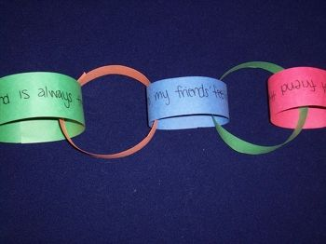 | Friendship  Now create one for a friend or a member of your family, listing the qualities that you appreciate about them. | Friendship  Write and acrostic poem about FRIENDSHIP, eg  F – For always being friendly and fun  R – Respecting me and others  I – Interesting and incredible…
Mindfulness/  Wellbeing | Heartbeat  - close your eyes and notice how quickly or slowly their heart is beating.  - think about your current state of emotion and consider if this might be connected to how quickly or slowly their heart is beating.  - stand and jump up and down on the spot ten times.  - return to sitting and feel their heartbeat again, noticing any changes.  - you may like to close their eyes and focus on their heartbeat until it slows back down. | Breathing:  Focus on your breathing, close your eyes and think about the following questions:  What is moving your hands? Is it the air filling your lungs?  – Can you feel the air moving in through your nose?  – Can you feel it moving out through your nose?  – Does the air feel a little colder on the way in and warmer on the way out?  – Can you hear your breath?  – What does it sound like? | Helping hands:  Help someone at home without them asking you. How does this make you feel? | Sense Countdown:  Think of:  - 5 things you can see  - 4 things you can touch  - 3 things you can hear  - 2 things you can smell  - 1 thing you can taste | Happy Drawing:  Draw a picture of something that makes you feel happy. You could annotate your drawing with reasons why

