Year 2: Autumn 1
Animals Including Humans
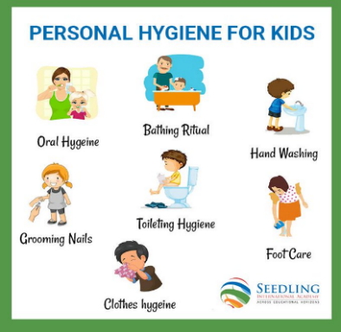  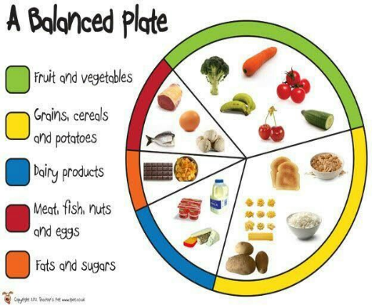  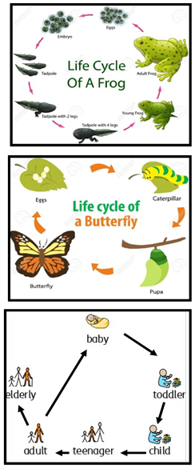  hygiene  A balanced diet  lifecycles |  | Vocabulary  animal  offspring  diet  exercise  hygiene  basic needs  survival  life cycle
What I already know:
Year 1
- Identify and name a variety of common animals that are carnivores, herbivores and omnivores.
- Identify, name, draw and label the basic parts of the human body and say which part of the body is associated with each sense.

What I will learn now:
Year 2  - Notice that animals, including humans, have offspring, which grow into adults.  - Find out about and describe the basic needs of animals, including humans, for survival (water, food and air).  - Describe the importance for humans of exercise, eating the right amounts of different types of food, and hygiene. | Key facts  - All living things grow and reproduce (make more of themselves)  - Some offspring look similar to their parents, but some do not  - All animals, including humans, need food, water and air to survive  - Humans need a balanced diet to be healthy  - Humans need to exercise to be healthy  - Exercise helps to build strong bones, strong muscles and good posture (standing straight and tall)  - Good personal hygiene is important to stop us spreading germs and diseases to other people.
What I will learn next:
Year 3
- Identify that animals, including humans, need the right types and amount of nutrition, and that they cannot make their own food; they get nutrition from what they eat.

