Year 5: Summer
Animals Including Humans (Strand: Biology)
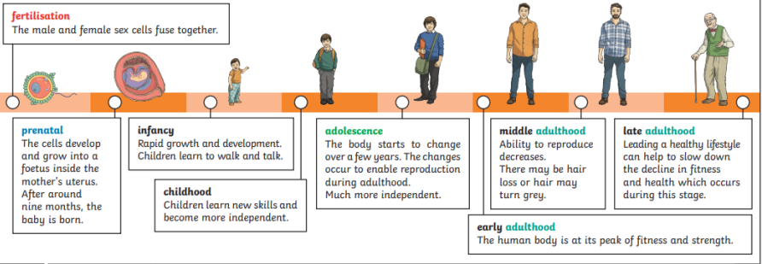 |  | Vocabulary  Adolescent  Adult  Baby  Child  Development  Foetus  Gestation  Human  Life expectancy  Puberty  Pre-natal  Reproduction  Toddler
What I already know:
Year 2
- Notice that animals, including humans, have offspring which grow into adults.
What I will learn now:
Year 5  - Describe the changes as humans develop to old age  - Describe the changes experienced in puberty  - Identify the indicate stages in growth  - compare development of humans to animals | Key facts  - Human development, the process of growth and change that takes place between birth and maturity.  - Different tissues and different regions of the body mature at different rates.  - The young child’s brain has basically the same structures as the adult brain.  - Infancy is a period of rapid change. Many toddlers learn to walk and talk at this stage.  - Adolescence is when the body starts to change and prepare itself for adulthood. Hormonal changes take place over a few years. This is also known as puberty.  - Puberty is the change that happens in late childhood and adolescence where the body starts to change because of hormones.  - Some changes include growth in height, more sweat, hair growth on arms and legs, under the armpits and on genitals, and growth in parts of the body such as male genitals and breasts.  - Females begin to menstruate. A cycle of between 2-7 days where woman pass blood and tissue to help the body prepare for the possible fertilisation of an egg  - Gestation is the process in which babies grow inside their mother's body before they are born.  - 7 life processes: movement, reproduction, sensitivity, growth respiration, excretion and nutrition
What I will learn next:
KS3
- Reproduction in humans (as an example of a mammal), including the structure and function of the male and female reproductive systems, menstrual cycle (without details of hormones), gametes, fertilisation, gestation and birth, to include the effect of maternal lifestyle on the foetus through the placenta.

Year 5: Summer
Animals Including Humans (Strand: Biology)
Question 1: Label each stage of the human timeline
Pre  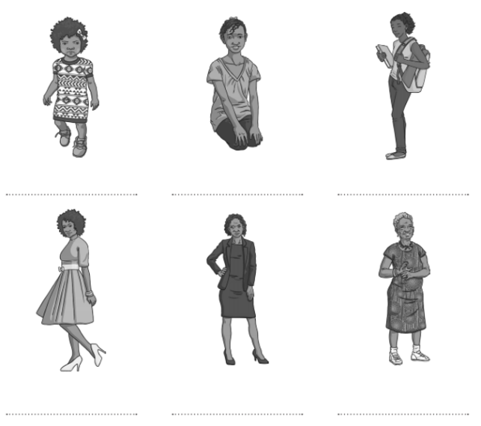 | Post
Question 2: If you were going to plot a child height and age as they grow on a graph. What would be on the X axis? What would be on the right?
Pre  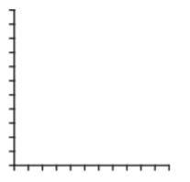  A) X Axis: ________________________________  B) Y Axis: ________________________________ | Post  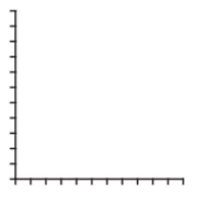  A) X Axis: ________________________________  B) Y Axis: ________________________________
Question 3: Why does your body need to make changes during puberty?
Pre | Post
Question 4: Write true or false next to each statement about puberty.
Pre  - Everyone finishes puberty at the age of 15 ___________  - Boys and girls both grow more hair during puberty ___________  - Sweat smells ___________  - Everyone grows and changes the same during puberty ___________  - Animals also go through puberty. ___________ | Post  1) Everyone finishes puberty at the age of 15 ___________  2) Boys and girls both grow more hair during puberty ___________  3) Sweat smells ___________  4) Everyone grows and changes the same during puberty ___________  5) Animals also go through puberty. ___________
Question 5: Circle all the statements which are true about people in old age
Pre  They always have memory loss They still need to exercise  They can still learn new things They are in their final stage of development  They will lose all their teeth They all need help to walk | Post  They always have memory loss They still need to exercise  They can still learn new things They are in their final stage of development  They will lose all their teeth They all need help to walk

