Year 1: Autumn 1 and Autumn 2
Animals Including Humans (Strand: Biology)
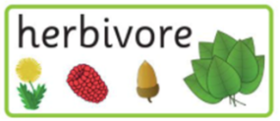  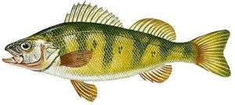  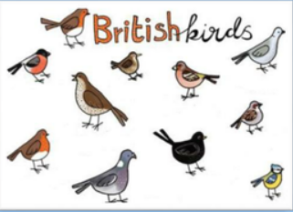  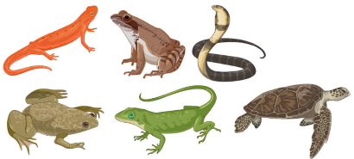  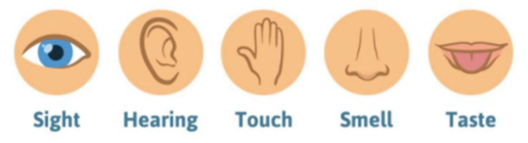  fish  birds  amphibians and reptiles |  | Vocabulary  bird  fish  amphibians  reptiles  mammals  carnivore  herbivore  omnivore  feathers  gills
What I already know:
Nursery and Reception

Humans
- Use your senses to explore natural materials
- Name and describe people who are familiar to you

What I will learn now:
Year 1  - Identify and name common animals including fish, amphibians, reptiles, birds and mammals.  - Identify and name common animals that are carnivores, herbivores and omnivores.  - Describe and compare the structure of a variety of common animals (fish, amphibians, reptiles, birds and mammals, including pets).  - Identify, name, draw and label the parts of the human body and say which part of the body matches which sense. | Key facts  - Reptiles are cold-blooded, have scales and usually lay eggs.  - Fish are similar to reptiles but also have fins and use gills to breathe under water.  - Birds are warm blooded, lay eggs and have feathers and wings.  - Amphibians are able to live on land and in water but their skin stays wet, they are also cold-blooded and lay their eggs in water.  - Mammals make milk, are warm blooded and have hair or fur; humans are part of this group.  - Carnivores are animals that eat only meat, herbivores eat only plants but omnivores eat both.  - Humans use their eyes to see, ears to hear, nose to smell, tongue to taste and hands to touch.
What I will learn next:
Year 2

- Describe how animals get their food from plants and other animals
- How a simple food chain works: identify and name different sources of food.

Year 1: Autumn 1and Autumn 2
Living Things Including Humans (Strand: Biology)
Question 1:
Pre | Post
Question 2:
Pre | Post
Question 3:
Pre | Post
Question 4:
Pre | Post
Question 5:
Pre | Post

