Year 5: Spring 2
Earth and Space (Strand: Physics)
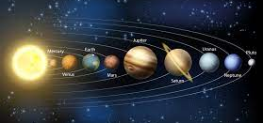 |  | Vocabulary  Earth  Axis  Rotate  Solar system  Planets  Orbits  Star  Universe  Milky way  Galaxies
What I already know:
Reception
- Explore the natural world around them.
- Describe what they see, hear and feel whilst outside.
Year 1
- Observe changes across the four seasons.
- Observe and describe weather associated with the seasons and how day length varies.
What I will learn now:
Year 5  - Describe the movement of the Earth, and other planets, relative to the Sun in the solar system.  - Describe the movement of the Moon relative to the Earth.  - Describe the Sun, Earth and Moon as approximately spherical bodies.  - Use the idea of the Earth’s rotation to explain day and night and the apparent movement of the Sun across the sky | Key facts  - The Sun is at the centre and the planets follow individual paths called orbits around it.  - They all travel in the same direction, but move at different speeds and take different times to complete one orbit.  - All planets within the solar system orbit the sun.  - The order of the planets, starting with the one closest to the Sun is: Mercury, Venus, Earth, Mars, Jupiter, Saturn, Uranus then Neptune.  - A moon is a celestial body that orbits a planet.  - The Earth, moon and sun are known as spherical bodies.  - The moon orbits around the Earth, the planets orbit around the sun and the sun remains stationary.  - The Earth Rotation around stationary sun creates the apparent movement of the sun across the sky.
What I will learn next:
KS3
- Gravity force, weight = mass x gravitational field strength (g), on Earth g=10 N/kg, different on other planets and stars; gravity forces between Earth and Moon, and between Earth and Sun (qualitative only).
- Our Sun as a star, other stars in our galaxy, other galaxies.
- The seasons and the Earth’s tilt, day length at different times of year, in different hemispheres.
- The light year as a unit of astronomical distance.

Year 5: Spring 2
Earth and Space (Strand: Physics)
Question 1: Join up these labels to the correct planet, star or satellite
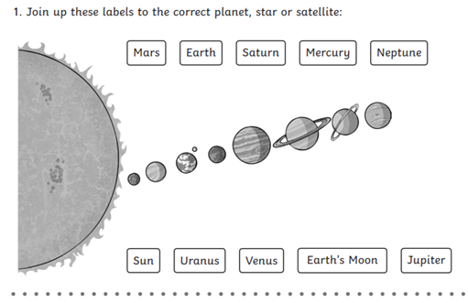  Pre | Post
Question 2: How long does it take for the earth to spin once on its axis?
Pre | Post
Question 3: Roughly what shape are the Earth, Sun and Moon?
Pre | Post
Question 4: Say whether the following statements are true or false
Pre  - The Earth orbits around the sun  - The sun is a planet.  - The earth is a satellite of the moon.  - The gravity of the sun keeps the planets in orbits. | Post  - The Earth orbits around the sun  - The sun is a planet.  - The earth is a satellite of the moon.  - The gravity of the sun keeps the planets in orbits.
Question 5: Shade in the circles to show the phases of the moon.
Pre  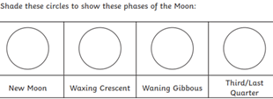  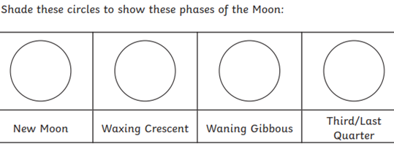 | Post  