Year 6: Spring
Electricity (Strand: Physics)
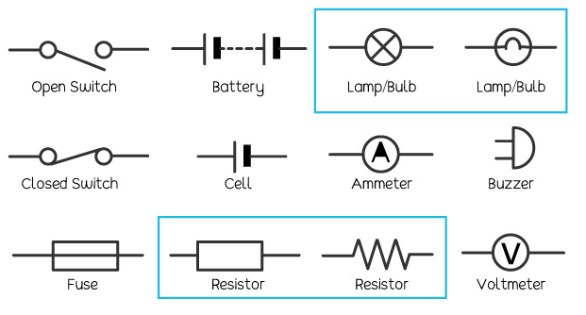 |  | Vocabulary  Circuit  Complete Circuit  Circuit Diagram, Circuit Symbol  Cell  Battery  Bulb  Buzzer  Motor  Switch  Voltage
What I already know:
Year 4
- Identify common appliances that run on electricity.
- Construct a simple series electrical circuit, identifying and naming its basic parts, including cells, wires, bulbs, switches and buzzers.
- Identify whether a lamp will light in a simple series circuit, based on whether the lamp is part of a complete loop with a battery.
- Recognise that a switch opens and closes a circuit and associate this with whether a lamp lights in a simple series circuit.
- Recognise some common conductors and insulators, and associate metals with being good conductors.
What I will learn now:
Year 5  - Associate the brightness of a lamp or the volume of a buzzer with the number and voltage of cells used in the circuit  - Compare and give reasons for variations in how components function, including the brightness of bulbs, the loudness of buzzers and the on/off position of switches  - Use recognised symbols when representing a simple circuit in a diagram. | Key Facts (filling the gaps)  Associate the brightness of a lamp or the volume of a buzzer with the number and voltage of cells used in the circuit  Compare and give reasons for variations in how components function, including the brightness of bulbs, the loudness of buzzers and the on/off position of switches  Use recognised symbols when representing a simple circuit in a diagram.
What I will learn next:
KS3
- Electric current, measured in amperes, in circuits, series and parallel circuits, currents add where branches meet and current as flow of charge.
- Potential difference, measured in volts, battery and bulb ratings; resistance, measured in ohms, as the ratio of potential difference (p.d.) to current.
- Differences in resistance between conducting and insulating components (quantitative).
- Static electricity.

