Year 6: Spring/Summer
Evolution and Inheritance (Strand: Biology)
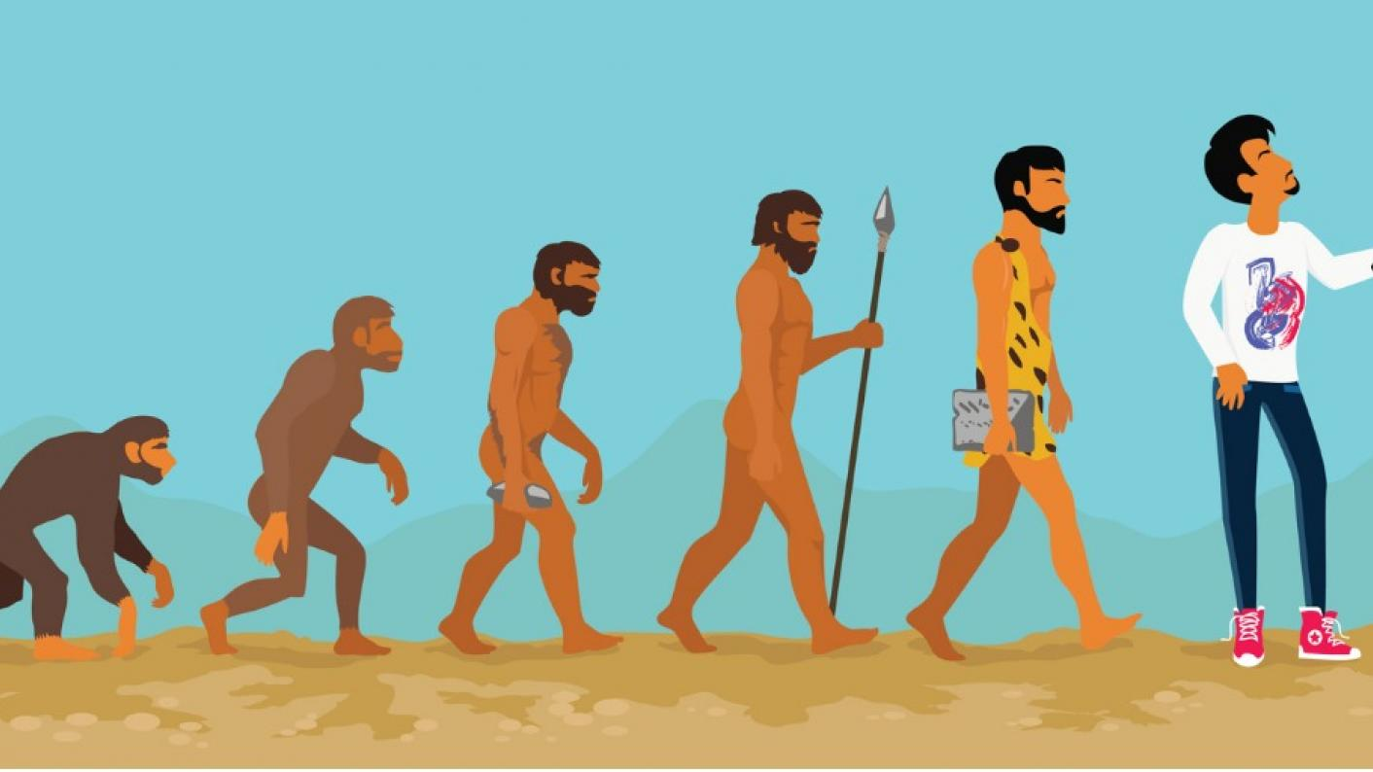 |  |  | Vocabulary  Characteristics  Environment  Species  Fossils  Adaptation  Appearance  Charles Darwin  Natural selection  Inheritance  Evolution  Natural selection  Extinct
What I already know:
Year 2  - Identify that most living things live in habitats to which they are suited and describe how different habitats provide for the basic needs of different kinds of animals and plants, and how they depend on each other.  - Notice that animals, including humans, have offspring which grow into adults.  Year 3  - Explore the part that flowers play in the life cycle of flowering plants, including pollination, seed formation and seed dispersal.  - Describe in simple terms how fossils are formed when things that have lived are trapped within rock. |  | Year 4  - Recognise that environments can change and that this can sometimes pose dangers to living things.  Year 5  - Describe the life process of reproduction in some plants and animals.
What I will learn now:
Year 6  - Recognise that living things have changed over time and that fossils provide information about living things that inhabited the Earth millions of years ago.  - Recognise that living things produce offspring of the same kind, but normally offspring vary and are not identical to their parents.  - Identify how animals and plants are adapted to suit their environment in different ways and that adaptation may lead to evolution. | Key facts  - Evolution occurs when there is competition to survive (natural selection) and differences within a species caused by inheritance and mutations.  - Inheritance is when a characteristic is passed on to the next generation.  - Genetic variation is the difference in DNA among individuals.  - Offspring are not identical to their parents, so species change over time.  - Natural selection is a process by which a species changes over time in response to changes in the environment, or competition between organisms, for the species to survive.  - Charles Darwin was an English naturalist, geologist and biologist, best known for his contributions to the science of evolution.  - His proposition that all species of life have descended over time from common ancestors is now widely accepted and considered a foundational concept in science.  - A fossil is known as the ancestral remains or impression of a prehistoric plant or animal embedded in rock and preserved in petrified form.
What I will learn next:
KS3
- Heredity as the process by which genetic information is transmitted from one generation to the next.
- A simple model of chromosomes, genes and DNA in heredity, including the part played by Watson, Crick, Wilkins and Franklin in the development of the DNA model.
- The variation between species and between individuals of the same species means some organisms compete more successfully, which can drive natural selection.
- Changes in the environment may leave individuals within a species, and some entire species, less well adapted to compete successfully and reproduce, which in turn may lead to extinction.

