Year 5: Spring 1
Forces (Strand: Physics)
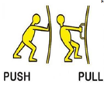  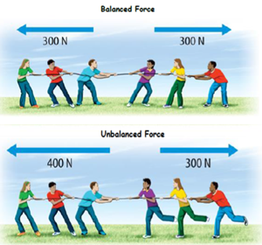 |  | Vocabulary  Gravity  Friction  Air resistance  Up thrust  Weight  Newton’s  Push  Pull  Balance  Particles
What I already know:
Year 3
- Compare how things move on different surfaces.
- Notice that some forces need contact between two objects, but magnetic forces can act at a distance.
- Observe how magnets attract or repel each other and attract some materials and not others.
- Compare and group together a variety of everyday materials based on whether they are attracted to a magnet and identify some magnetic materials.
- Describe magnets as having two poles.
- Predict whether two magnets will attract or repel each other, depending on which poles are facing.
What I will learn now:
Year 5  - Explain that unsupported objects fall towards the Earth because of the force of gravity acting between the Earth and the falling object.  - Identify the effects of air resistance, water resistance and friction that act between moving surfaces.  - Recognise that some mechanisms, including levers, pulleys and gears, allow a smaller force to have a greater effect. | Key facts  - Gravitational force is a pull towards the centre of an object such as the Earth. All objects have a gravitational force, but the size of the force depends on the mass of the object.  - Friction is the force from two surfaces rubbing together.  - When objects fall through the air, the air resistance is the force that acts in the opposite direction of gravity.  - Up thrust in water is the force pushing up against an object. If this force balances the gravitational force pulling the object down, then it will float.  - If you want to lift a heavy weight, there's only so much force your muscles can supply, even if you are the world's strongest man. But use a simple machine such as a pulley and you can multiply the force your body produces.
What I will learn next:
KS3
- Forces as pushes or pulls, arising from the interaction between two objects.
- Using force arrows in diagrams, adding forces in one dimension, balanced and unbalanced forces.
- Moment as the turning effect of a force.
- Forces: associated with deforming objects; stretching and squashing –springs; with rubbing and friction between surfaces, with pushing things out of the way; resistance to motion of air and water.
- Forces measured in Newtons, measurements of stretch or compression as force is changed.

Year 5: Spring 1
Forces (Strand: Physics)
Question 1: In what unit do we measure force?
Pre | Post
Question 2: What is the name of the force that pulls things towards the centre of the Earth?
Pre | Post
Question 3: Explain why astronauts move in a bouncy way on the moon
Pre  _____________________________________________  _____________________________________________  _____________________________________________  _____________________________________________ | Post  _____________________________________________  _____________________________________________  _____________________________________________  _____________________________________________
Question 4: Label the force that is pushing against this swimmer in the water and parachute in the air.
Pre  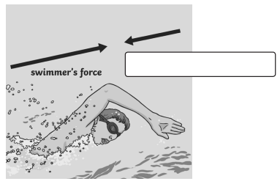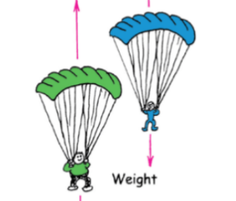 | Post
Question 5: Name these three mechanisms that make things easier to do as they lessen the force needed to be used.
Pre  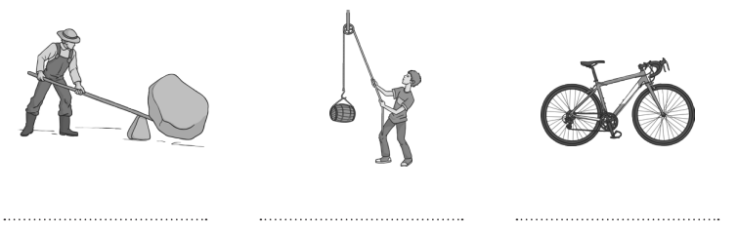 | Post

