Year 6: Spring
Light (Strand: Physics)
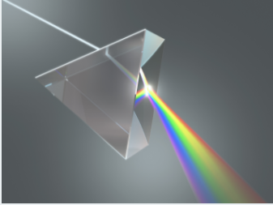 |  | Vocabulary  Light source  Light rays  Reflect  Shadows  Block  Patterns  Periscope  Translucency  Opaque  Angle of incidence  Dark
What I already know:
Year 3
- Recognise that they need light to see things and that dark is the absence of light.
- Notice that light is reflected from surfaces.
- Recognise that light from the sun can be dangerous and that there are ways to protect their eyes.
- Recognise that shadows are formed when the light from a light source is blocked by an opaque object.
- Find patterns in the way that the size of shadows changes.
Year 5
- Compare and group together everyday materials based on their properties, including their hardness, solubility, transparency, conductivity (electrical and thermal), and response to magnets.
What I will learn now:
Year 6  - Recognise that light appears to travel in straight lines.  - Use the idea that light travels in straight lines to explain that objects are seen because they give out or reflect light into the eye  - Explain that we see things because light travels from light sources to our eyes or from light sources to objects and then to our eyes  - Use the idea that light travels in straight lines to explain why shadows have the same shape as the objects that cast them. | Key facts  - The pupils in our eyes change size to let more light in when it's dark or less light in when it's bright and this is important because too much light can damage our eyes.  - Light travels as a wave, but unlike sound waves or water waves, it does not need any matter or material to carry its energy along.  - Shadows are the same shape as the objects which cast them because light travels in straight lines  - The ray of light approaching an object is known as the incident ray, whereas the ray of light leaving the object is known as the reflective ray.  - The normal line divides the angle between the incident ray and the reflected ray into two equal angles.  - The angle between the incident ray and the normal is known as the angle of incidence whereas the angle between the reflected ray and the normal is known as the angle of reflection.  - The law of reflection states that when a ray of light reflects off a surface, the angle of incidence is equal to the angle of reflection
What I will learn next:
KS3
- The similarities and differences between light waves and waves in matter.
- Light waves travelling through a vacuum; speed of light.
- The transmission of light through materials: absorption, diffuse scattering and specular reflection at a surface.
- Use of ray model to explain imaging in mirrors, the pinhole camera, the refraction of light and action of convex lens in focusing (qualitative), the human eye.
- Light transferring energy from source to absorber leading to chemical and electrical effects; photo-sensitive material in the retina and in cameras.
- Colours and the different frequencies of light, white light and prisms (qualitative only); differential colour effects in absorption and diffuse reflection.

