Year 6: Summer
Living Things and Their Habitats (Strand: Biology)
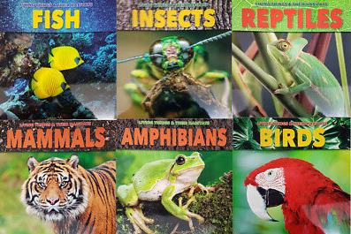 |  | Vocabulary  Offspring  Sexual reproduction  Characteristics  Suited  Adapted  Environment  Inherited  Species  Fossils  Virus  Fungus  Bateria
What I already know:
Year 2
- Describe the importance for humans of exercise, eating the right amounts of different types of food, and hygiene.
Year 3
- Identify that animals, including humans, need the right types and amount of nutrition, and that they cannot make their own food; they get nutrition from what they eat.
Year 4
- Describe the simple functions of the basic parts of the digestive system in humans.
- Identify the different types of teeth in humans and their simple functions.
What I will learn now:
Year 6  - Identify and name the main parts of the human circulatory system, and describe the functions of the heart, blood vessels and blood.  - Recognise the impact of diet, exercise, drugs and lifestyle on the way their bodies function.  - Describe the ways in which nutrients and water are transported within animals, including humans. | Key facts  - Living things can be animals, plants, fungus or microorganisms such as bacteria.  - Carl Linnaeus developed a classification system called Systems Naturae in 1735.  - This work allowed scientists to classify all living things, according to their similarities.  - Living things can be classified as animals, plants, fungus or microorganisms.  - Animals can be classified as vertebrates or invertebrates.  - Vertebrates can be classified as mammals, reptiles, birds, amphibians and fish.  - Invertebrates can be classified as crustaceans, insects, annelids and arachnids.  - Vertebrates have a backbone inside their bodies.
What I will learn next:
KS3
- The consequences of imbalances in the diet, including obesity, starvation and deficiency diseases.
- The effects of recreational drugs (including substance misuse) on behaviour, health and life processes.
- The structure and functions of the gas exchange system in humans, including adaptations to function.
- The mechanism of breathing to move air in and out of the lungs.
- The impact of exercise, asthma and smoking on the human gas exchange system.

Year 6: Spring/Summer
Living Things and Their Habitats (Strand: Biology)
Question 1: Name the three types of microorganisms.
Pre | Post
Question 2: What categories could you classify animals in?
Pre | Post
Question 3: What is the main difference between vertebrates and invertebrates?
Pre | Post
Question 4: Name a scientist who has studied living things and contributed to their classification.
Pre | Post
Question 5: Which of the following animals is a marsupial? fox, pelican, kangaroo, spider
Pre | Post
Question 6: Write a key characteristic of the amphibians
Pre | Post

