Year 5: Summer 1
Living Things and their Habitats (Strand: Biology)
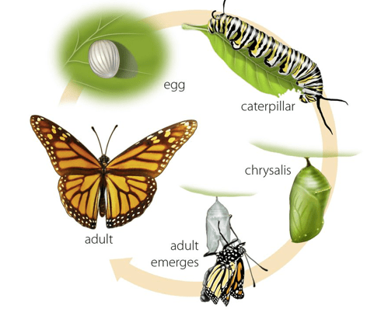  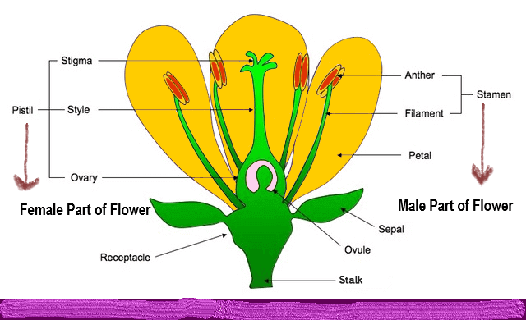 |  |  | Vocabulary  Life cycle  Reproduce  Sexual  Sperm  Fertilises  Egg  Live young  Metamorphosis  Asexual  Plantlets  Runners  Bulbs  Cuttings
What I already know:
Year 2
- Notice that animals, including humans, have offspring which grow into adults.
Year 3
- Explore the part that flowers play in the life cycle of flowering plants, including pollination, seed formation and seed dispersal.
What I will learn now:
Year 5  - Describe the differences in the life cycles of a mammal, an amphibian, an insect and a bird.  - Describe the life process of reproduction in some plants and animals. | Key facts  - Reproduction is when an animal or plant produces one or more individuals like itself:  - Sexual reproduction: requires two parents with male and female gametes (cells) will produce offspring that is like but not identical to the parent  - Asexual reproduction: will produce offspring that is identical to the parent requires only one parent  - Male gametes can be found in the pollen.  - Female gametes can be found in the ovary (they are called ovules).  - Pollination occurs when pollen from the anther is transferred to the stigma by bees and other insects.  - The pollen then travels down and meets the ovule. When this happens, seeds are formed - this is called fertilisation.  - Seeds are then dispersed so that germination can begin again.  - Some plants, such as daffodils and potatoes, can also produce offspring using asexual reproduction  - The life cycles of mammals, birds, amphibians and insects have similarities and differences.  - One difference is that amphibians and insects go through the process of metamorphosis. This is when the structure of their bodies changes significantly as they grow (for example, from tadpole to frog or caterpillar to butterfly).
What I will learn next:
KS3
- Reproduction in humans (as an example of a mammal), including the structure and function of the male and female reproductive systems, menstrual cycle (without details of hormones), gametes, fertilisation, gestation and birth, to include the effect of maternal lifestyle on the foetus through the placenta.
- Reproduction in plants, including flower structure, wind and insect pollination, fertilisation, seed and fruit formation and dispersal, including quantitative investigation of some dispersal mechanisms.
Year 5: Summer 1
Living Things and their Habitats (Strand: Biology)
Question 1: Complete the table about mammals, amphibians, insects, birds and reptiles. One has been done for you.
Pre  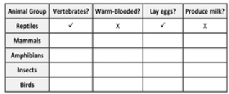 |  | Post
Question 2: What is a life cycle? Can you give an example?
Pre |  | Post
Question 3: Label the stages of the life cycle of a frog.
Pre  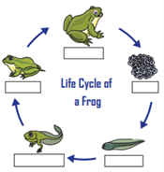 |  | Post
Question 4: Can you label the parts of a flower?
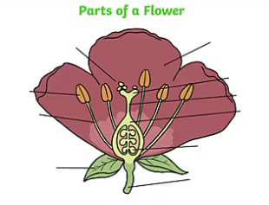  Pre  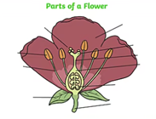 |  | Post
Question 5: What is pollination?
Pre |  | Post

