Year 2: Spring 2 and Summer 1
Living Things and their Habitats
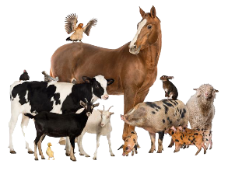  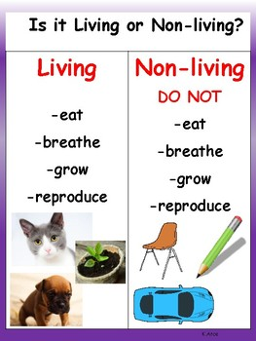  Habitats  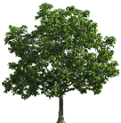  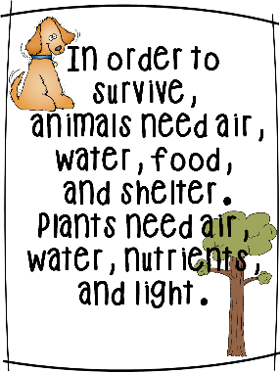  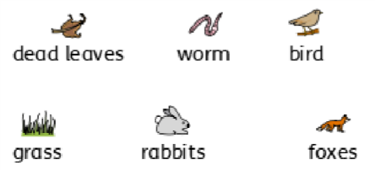  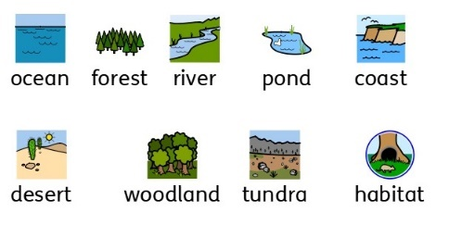  Food chains |  | Vocabulary  living and dead  never been alive  suitable  basic needs  food chain  habitat
What I already know:
Year 1
Plants  - The names of different plants  - How to identify and describe plants and trees  - Changes across the four seasons (seasonal changes) | Animals, including Humans  - The names of some carnivores, herbivores and omnivores  - How to describe and compare some common animals  - How to name a variety of common animals
What I will learn now:
Year 2  - Compare things that are living, dead, and things that have never been alive  - All living things have suitable and unsuitable habitats based on their features and survival needs  - Understand that most living things live in habitats to which they are suited  - Describe how different habitats provide for the basic needs of different animals and plants  - Identify and name plants and animals in their habitats and micro-habitats  - Describe how animals get their food from plants and from other animals  - Use a simple food chain, and identify and name different sources of food | Key facts  - All objects are either living, dead or have never been alive.  - Living things are plants (including seeds) and animals.  - Dead things include dead animals and plants, and parts of plants and animals that are no longer attached  - A wooden object is classed as dead  - Objects made of rock, metal and plastic have never been alive  - A habitat describes where a living thing lives and a micro habitat is a smaller habitat for smaller living things  - Food chains show how living things depend on each other for food
What I will learn next:
Year 4
- Recognise that living things can be grouped in different ways
- Explore and use classification keys to group, identify and name a variety of living things
- Recognise that environments can change and that this can sometimes pose dangers to living things
- Construct and interpret food chains; identifying producers, predators and prey

