Year 1: Summer 2
Plants (Strand: Biology)
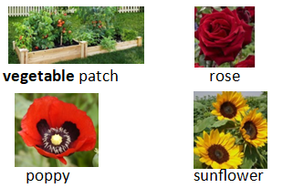  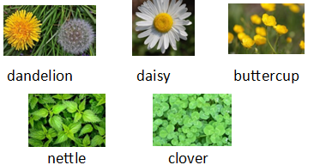  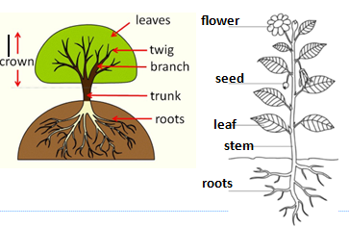  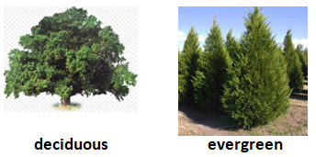 |  | Vocabulary  common  deciduous  evergreen  flower  petal  plant  roots  seeds  stem  tree  trunk
What I already know:
Nursery and Reception
Plants  - Plant a seed; care for growing plants  - Understand life cycles  - Respect and care for the environment | Living Things and their habitats  - Explore the natural world  - Recognise differences in the environment
What I will learn now:
Year 1  - Identify and name common wild and garden plants  - Identify and name deciduous and evergreen trees  - Identify and describe the basic structure of flowering plants, including trees  - Sort and group familiar plants; say what is the same and what is different | Key facts  - Plants need water and light to grow well  - Plants absorb water through their roots  - The stem of the plant or trunk of the tree helps the plant or tree to stay upright  - Deciduous trees lose their leaves in autumn and winter  - Evergreen trees keep their leaves throughout the year  - Seeds are not dead  - When plants and flowers are cut or picked, they are no longer alive  - Trees and plants change over time as they grow
What I will learn next:
Year 2

- Observe and describe how seeds and bulbs grow into mature plants.
- Find out and describe how plants need water, light and a suitable temperature to grow and stay healthy.
- Identify and name a variety of plants and animals in their habitats, including microhabitats.

Year 1: Autumn 1 & 2
Plants (Strand: Biology)
Question 1:
Pre | Post
Question 2:
Pre | Post
Question 3:
Pre | Post
Question 4:
Pre | Post
Question 5:
Pre | Post

