Year 2: Summer 2
Plants
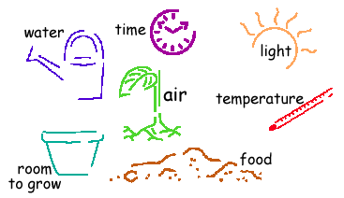  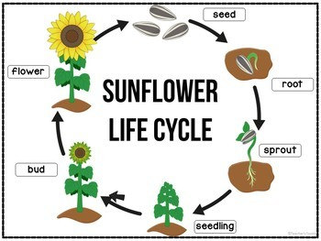  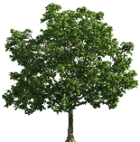  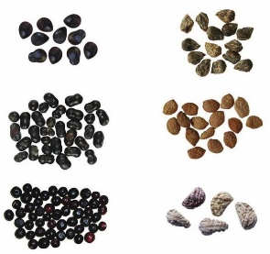  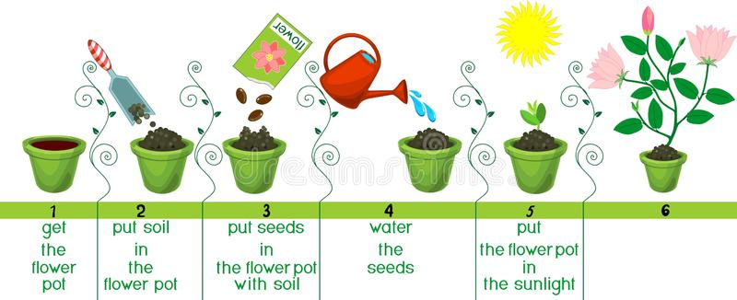  seeds  basic needs |  | Vocabulary  light and shade  sun  warm  cool  water  grow  healthy
What I already know:
Year 1
- The names of some different plants and trees
- How to identify and describe the structure of plants and trees
- Changes across the four seasons (seasonal changes)

What I will learn now:
Year 2  - how seeds and bulbs grow into mature plants  - that plants need water, light and a suitable temperature to grow and stay healthy | Key facts  - Plants can grow from either seeds or bulbs  - Young plants called seedlings continue to grow into mature plants  - Mature plants may have flowers which then develop into seeds, berries, fruits etc.  - Seeds and bulbs need to be planted outside at particular times of year and they will grow at different rates.  - Some plants are better suited to growing in sun and some grow better in shade  - Plants also need different amounts of water and space to grow well and stay healthy
What I will learn next:
Year 3
- Identify and describe the functions of different parts of flowering plants:
- roots, stem/trunk, leaves and flowers
- Explore the needs of plants for life and growth (air, light, water, nutrients from soil, and room to grow) and it is different from plant to plant
- Investigate the way in which water is transported within plants
- Explore the part that flowers play in the life cycle of flowering plants, including pollination, seed formation and seed dispersal

