Year 1: Autumn/Spring/Summer 1 & 2
Everyday Materials (Strand: Physics)
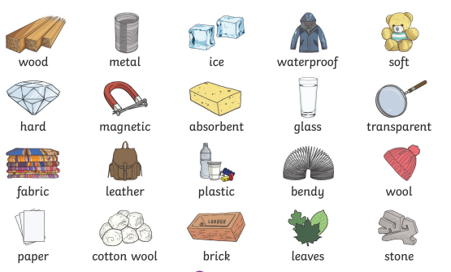 |  | Vocabulary  wood  plastic  glass  metal  brick  hard / soft  stretchy / not stretchy  bendy / not bendy  rough / smooth  shiny / dull  reflective / dull  waterproof / absorbent
What I already know:
Nursery and Reception
Materials
- Use all their senses in hands-on exploration of natural materials.
- Explore collections of materials with similar and/or different properties.
- Talk about the differences between materials and changes they notice.
What I will learn now:
Year 1  - Know the difference between an object and what it is made from  - Name different everyday materials including wood, plastic, glass, metal, water and rock  - Describe the properties of materials and say what they are like  - Compare and group materials according to what they are like (their properties) | Key facts  - Objects are things that can be used  - Materials are what an object is made from  - Objects can be made from different materials  - Some materials have the same properties as other materials;  -wood and brick are both hard  -glass and metal are both not bendy  -plastic and glass are both waterproof
What I will learn next:
Year 2
- Identify and compare the suitability of a variety of everyday materials, including wood, metal, plastic, glass, brick, rock, paper and cardboard for particular uses.
- Find out how the shapes of solid objects made from some materials can be changed by squashing, bending, twisting and stretching.

Year 1: Autumn/Spring/Summer 1 & 2
Everyday Materials (Strand: Physics)
Question 1:
Pre | Post
Question 2:
Pre | Post
Question 3:
Pre | Post
Question 4:
Pre | Post
Question 5:
Pre | Post

