Year 1: ongoing throughout the year
Seasonal Changes (Strand: Physics)
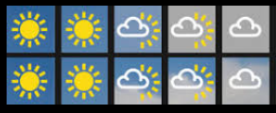  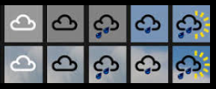  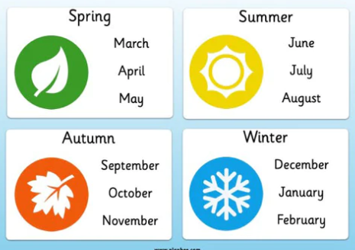  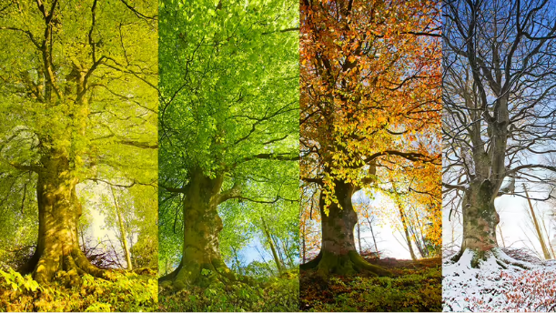  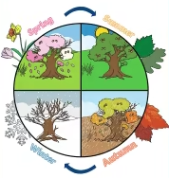  The 4 seasons  weather symbols |  | Vocabulary  seasons  Spring  Summer  Autumn  Winter  weather  day  month  year
What I already know:
Nursery and Reception

- Describe what they see, hear and feel whilst outside.
- Understand the effect of changing seasons on the natural world around them.
- Note and record the weather

What I will learn now:
Year 1  - Observe changes that happen in Autumn, in Winter, in Spring and in Summer  - Observe changes across the 4 seasons  - Notice the weather in different seasons  - Describe the weather in different seasons  - Notice and describe how the length of the day is different depending on the season | Key facts  - There are 4 seasons in the year: spring, summer, autumn and winter  - Four seasons are formed in one year due to the earth travelling around the sun.  - In spring the weather usually turns warmer, trees begin to grow their leaves, plants start to flower and young animals such as chicks and lambs are born.  - In the UK, Summer has the longest days and the highest temperatures.  - Autumn is the time when deciduous trees shed their leaves  - In the UK, Winter is the season with the shortest days and the lowest temperatures.
What I will learn next:
Year 3

Light
- find patterns in the way that the size of shadows change
Year 5

Earth and Space
- use the idea of the Earth’s rotation to explain day and night and the apparent movement of the sun across the sky

Year 1: Autumn 1and Autumn 2
Living Things Including Humans (Strand: Biology)
Question 1:
Pre | Post
Question 2:
Pre | Post
Question 3:
Pre | Post
Question 4:
Pre | Post
Question 5:
Pre | Post

