Year 2: Autumn 2 and Spring 1
Uses of Everyday Materials
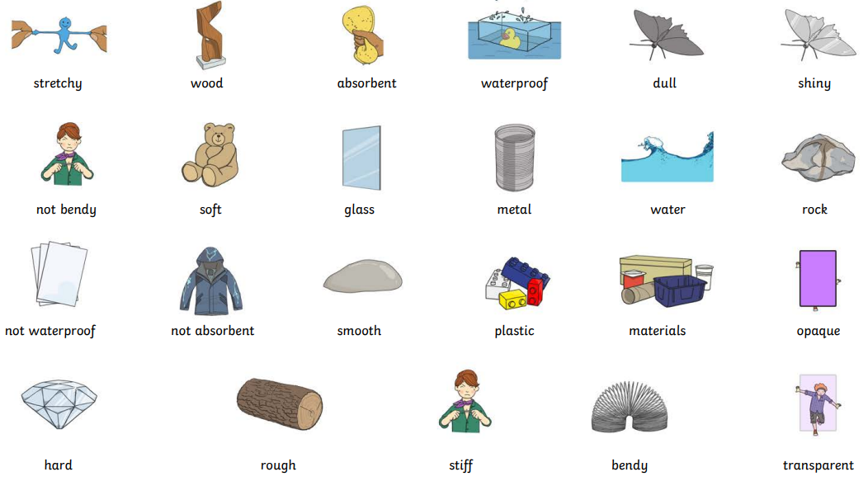 |  | Vocabulary  absorbent  rough  stretchy  waterproof  elastic  fabrics  glass  metal  natural  wood
What I already know:
Year 1
- Distinguish between an object and the material from which it is made.
- Identify and name a variety of everyday materials, including wood, plastic, glass, metal, water, and rock.
- Describe the simple physical properties of a variety of everyday materials.
- Compare and group together a variety of everyday materials on the basis of their simple physical properties.

What I will learn now:
Year 2  - Identify how different, everyday materials are suited to a particular use  - Compare a variety of everyday materials, including wood, metal, plastic, glass, brick, rock, paper and cardboard  - Find out how the shapes of solid objects can be changed by squashing, bending, twisting and stretching. | Key facts  - Different materials have different properties  - Properties describe what a material is like, for example: hard, strong, weak, flexible  - Materials are used for things based on their properties  - Metal can be used for coins, cans, cars and table legs  - Wood can be used for matches, floors and furniture  - Different materials can be used for the same thing, for example spoons can be made from plastic, wood or metal, but not normally glass.
What I will learn next:
Year 3
Rocks
- Compare and group together different kinds of rocks on the basis of their appearance and simple physical properties.

Forces
- Notice that some forces need contact between two objects, but magnetic forces can act at a distance.

